Specification for Wetland Persistence Model

David Conklin, Oregon Freshwater Simulations, and Kyla Zaret, Portland State University, 11/25/20

Revised to reflect as-built code, David Conklin, 7/30/21

Contents

Context 2

Model and Simulation Overview 2

McKenzie wetlands in the initial versions of the IDU, HRU, and Reach data layers 3

Data changes for better representation of wetlands 3

Simulation of changes in wetlands over time 4

How wetlands will be represented in the model 5

Attributes of interest in the wetlands study 6

A WETNESS attribute 7

Calculating the exchange of water between the wetland and the reach 8

Wetland IDU parameters 8

Reach parameters 8

Evapotranspiration from wetlands 9

Evolution of wetlands 9

Loss (or gain) of wetlands 9

Reality check 10

Summary of additional data needed 10

Placeholder data 12

Original wetland land use/land cover categories at the beginning of the project 12

Wetland land use/land cover categories to be used for code development 13

Transitions for the state-and-transition model 15

References 15

Figure 1. CW3M: Wetland Persistence; other wetland attributes 11

Figure 2. CW3M: Wetland Persistence; linking attributes to processes 12

# Context

This document is the second of two specifications which are deliverables for the McKenzie wetlands research project. Please refer to the first one, “Specification for Thermal Loading Estimator”, dated 11/12/20, for context information.

This document was originally called for in Agreement Amendment 1 to the contract between Oregon Freshwater and Land Craft. The requirement was

“***Task* 1 (B) Wetland persistence model specifications**

***Task Description***  Wetland persistence CW3M model specifications

***Deliverable*** (B) A wetland persistence (fate) model incorporating expert guidance on critical wetland attributes and providing projections on the persistence of wetlands under CW3M climate models. Model performance specification is reasonable estimation of wetland persistence over projected timespans as determined by expert guidance and project team.”

The document version dated 11/25/20 was delivered to Land Craft in fulfillment of Task 1 (b) of the Land Craft contract.

In early 2021, Freshwater began implementation of the wetland persistence model. The Freshwater-Land Craft contract was terminated by Freshwater in spring 2021. In July 2021 a new Freshwater contract was set up directly with the Lane Council of Governments (LCOG). The first item in the scope of work in the new contract is to update the wetland persistence spec to reflect design decisions made during the implementation work to date.

# Model and Simulation Overview

Historical data for the nine year period 2010-18 is being used for calibration. Since gage data and other actual data is now available for the two years 2019-2020, those 2 years are being used to assess the skill of the model. Future simulations will be made for the forty year period 2021-2060. Climate data for the future simulations remains to be selected as of 7/28/21.

CW3M’s IDU layer for the McKenzie basin currently has 16,883 polygons with a total area of 330,708 hectares. Its reach layer has 1047 reaches. There are 954 HRUs, representing contiguous smaller areas which drain to a single reach or to several adjacent contiguous reaches. HRUs are made up of IDUs; HRU boundaries are coincident with IDU boundaries. CW3M’s spatial data files use the NAD 1983 UTM Zone 10N projected coordinate system.

CW3M’s native units are metric. In the CW3M output files, areas are generally presented in square meters and hectares, water depths in meters or millimeters, volumes in cubic meters, flows in cubic meters per second (cms), temperatures in Celsius, and precipitation in millimeters of water. However, some reports use acre-feet and cubic feet per second. By convention, units are identified in the title of the report and/or in the individual column headers.

CW3M has a 3-layer land use/land cover (LULC) hierarchy. IDU attributes LULC_A, LULC_B, and VEGCLASS contain the current class codes for each IDU. For wetland IDUs, “VEGCLASS” for the third level is a misnomer: wetland vegetation types are actually encoded in LULC_B, and the hydroperiod is encoded in the third layer. To reduce confusion, in this document the IDU attribute for the third layer of the LULC hierarchy will usually be called LULC_C, rather than VEGCLASS. As of the beginning of this project in 2020 there were only 8 LULC_A categories: Unknown, Developed, Agriculture, Other veg., Forest, Barren, Wetlands, and Water-snow-ice. At that time the top and middle levels in the hierarchy each had only a single Wetlands category (LULC_A = 6 and LULC_B = 61), and the bottom level had just two, Woody Wetlands (VEGCLASS = 190) and Herbaceous Wetlands (VEGCLASS = 195). Sixty-five IDUs totaling 519 hectares were classified as wetlands. All but four of the wetland IDUs were classified as woody wetlands; those total 500 hectares. The other four IDUs, classified as herbaceous wetlands, are near the point where the McKenzie flows into the Willamette.

The existing representation of wetlands in CW3M is a legacy of the WW2100 project, in which wetlands were not a focus. For the current project, we need to improve the wetland representation. We will add many more wetland categories to the middle and bottom levels of the LULC hierarchy. These data improvements are necessary to meet the model performance specification, but the identification of the new categories and the preparation of a revised IDU GIS layer to make use of them requires expert knowledge about wetlands and GIS which is outside the scope of Freshwater’s modeling and simulation services. In fall 2020, Kyla Zaret, a wetlands researcher, helped Freshwater draft a revision to the wetlands portion of the LULC hierarchy, which is described below in the section titled “Placeholder data”. The new LULC hierarchy reflects categories used in the National Wetlands Inventory. The old LULC_A = 6 code for “Wetlands” is being replaced by LULC_A = 62 for Palustrine non-isolated wetland. Wetland LULC_B codes will represent wetland vegetation types, and wetland LULC_C codes will represent hydroperiod.

# McKenzie wetlands in the initial versions of the IDU, HRU, and Reach data layers

There is an Excel spreadsheet named “Wetlands.xslx” in the CW3M Digital Handbook folder. It has data for wetlands in both the McKenzie and Clackamas basins. Initial data for the McKenzie shows 18 wetlands ranging in size from 7 to 162 ha and totaling 519 ha. For comparison, Clackamas data has 12 wetlands, ranging in size from 5 to 38 ha and totaling 204 ha.

# Data changes for better representation of wetlands

Note that CW3M has a convention that the LULC attributes of an IDU may change only from one year to the next, not multiple times within a single year. The items below are recommendations regarding preparation of a revised IDU layer. Freshwater will rely on LCOG to supply the new layer and associated data.

Recommendation #1. Use the LULC_A attributes of wetland IDUs to represent things that rarely if ever change, such as landscape position and soils.  Use the second level LULC attribute (LULC_B) for wetland vegetation type (i.e. meadow, shrubby, woodland, etc.), which may change over multiyear time periods. Use the third level LULC attribute (LULC_C) to represent categories related to the characteristic hydroperiod (i.e. seasonal, persistent, etc.). Use other IDU attributes which are not part of the LULC hierarchy to represent things which change seasonally or daily, for example a WETNESS attribute for inundation depth and soil moisture.

Recommendation #2. Develop a shapefile which represents historic, current, and potential future wetlands, divided into polygons by LULC_C values.  Intersect that shapefile with the existing IDU shapefile to produce a new IDU shapefile with more IDUs, where the boundaries of the IDUs in the original IDU shapefile are coincident with the outer boundaries of contiguous sets of 1 or more IDUs in the new IDU shapefile. Remove tiny IDUs created as artifacts of the intersection by merging them into adjacent IDU, while preserving the property that the boundaries of the original IDUs are coincident with the boundaries of contiguous sets of new IDUs.

Recommendation #3. Populate initial condition data attributes in the new IDU layer with data for those attributes in the original IDU layer, except assign LULC_A, LULC_B, and LULC_C attribute values for wetland IDUs using the new classes developed in the first step.

# Simulation of changes in wetlands over time

CW3M will be used in this study to address the question of how McKenzie basin wetlands might change over the next four decades. In order to produce results which are relevant, the model must be able to produce changes in the wetlands in response to other changes, both natural and anthropogenic. Natural changes as used here are changes to the precipitation regime, seasonal temperatures, and so on. Anthropogenic changes would include development encroaching on wetland, changes in the upstream flow regime due to changes in reservoir operations or irrigation withdrawals, and so on. As of the beginning of the study, CW3M treats IDU wetlands as static: once a wetland, always a wetland. Real estate development encroachment on wetlands is not represented in CW3M’s land use model, nor is the loss of wetlands due to drainage, drought, or conversion to agriculture. At the very least, we will need to implement logic to tie the states of the various wetland IDUs to the quantity of water available, as precipitation and from upstream. And we will need new logic to tie the temperature and volume of the water flowing out to the temperature and volume of the water flowing in and to the type of wetland. We will adapt CW3M’s state-and-transition model (STM) for simulating transitions from one wetland type to another.

CW3M can aggregate results from daily to yearly on either a calendar year basis or a water year basis. For this study, a water year basis seems more appropriate. Climate datasets begin on January 1st and end on December 31st. Simulation runs begin on January 1st and end on December 31st, regardless of whether the simulation results are aggregated on a calendar basis or water year basis. This has the consequence that when a 51-year simulation run is carried out, water year results are presented for only 50 complete water years, starting with October of the first calendar year and ending with September of the final calendar year. For example, when CW3M is run for the 51 (calendar) years 2010-2060, it produces results for only 50 complete water years, 2011-2060. Water years are named by the calendar year in which they end.

# How wetlands will be represented in the model

In CW3M, the areas and shapes of IDUs are fixed in the model’s initial data and do not change during the simulation. This has the consequence that, in a given simulation year, an IDU may be classified (the LULC_A attribute) as a wetland in its entirety or as not-a-wetland (e.g. agricultural or forested) in its entirety, but not as a combination of wetland and not-a-wetland. From one simulation year to the next, the classification of an IDU can be changed, for example from wetland to agricultural or vice versa. As noted previously, as of the beginning of this project, in CW3M wetlands are static; there is no logic to change an IDU’s LULC_A attribute from wetland (LULC_A=6) to anything else, nor any logic to change from something else to the wetland value. New logic to do so is discussed later in the section titled “Loss (or gain) of wetlands”.

The condition of a real wetland changes both seasonally and interannually. A WETNESS attribute has been added to represent how wet a wetland IDU is on a given day. The value of the WETNESS attribute is set in the daily simulation loop. The WETNESS attribute is discussed below in the section titled “A WETNESS attribute”.

CW3M represents a wetland IDU as a flat-bottomed pool with soil at the bottom and vertical sides of uniform height. The vegetation type and water depth are taken as uniform across the area of the IDU. This representation supports outputs for water temperature and water depth whenever the wetland is inundated, and the degree to which the soil is saturated when it is not inundated.

Conceptually, each wetland IDU adjacent to a reach may be visualized as a pool adjacent to a channel. When the wetland is wet and flow in the channel is low, water moves out of the pool into the channel by overflowing the side of the pool, and it can also move through the soil to the channel. When the wetland is dry and flow in the channel is higher, water can move from the channel into the pool, over the banks of the channel. CW3M does not have a mechanism for moving water laterally out of the channel directly into the soil of the adjacent IDU. CW3M does not distinguish generally between rheic and hyporheic flow, but does account for the volume and temperature of water entering the stream laterally from runoff.

The pool has a capacity (IDU attribute WETL_CAP, in units of depth). In this simple wetland model, we parameterize the reach with two values, a threshold flow (reach Q_CAP, in cms), and a fraction (reach QSPILL_FRC). Water always flows longitudinally down the channel, but at flow rates above Q_CAP, the portion of the flow above Q_CAP is divided between flow down channel and flow laterally over the sides of the channel into the adjacent pool. The flow rate from the reach to the pool is a fraction (QSPILL_FRC) of the total flow amount in excess of Q_CAP.

A wetland IDU separated from a stream by another wetland IDU may be visualized as a second pool adjacent to the first but on the other side from the channel. The rim of the second pool is at the same height as the first pool, but the bottom of the second pool may be higher than the bottom of the first pool, so that the capacity per unit area of the second pool may be smaller than the capacity per unit area of the first pool. The two pools are connected at the level of the bottom of the second pool, so the water level is the same in the two pools, as long as it is high enough in the first pool to reach the level of the bottom of the second pool.

The conceptualization described so far allows for nourishment of the wetland idus from a nearby reach, but it does not account for lateral flow into the wetlands from the soil of adjacent non-wetland IDUs. Nor does it account directly for a wetland slowing the runoff from upland precipitation. CW3M uses a version of the HBV precipitation-runoff model. HBV, at least as in CW3M, represents only lateral flow from the land into the stream, not from one parcel of land to an adjacent parcel. Even with these omissions, the conceptualization described so far may result in reducing the hydrograph peaks, since some of the water will detour into the adjacent pools on its way downstream.

Elaboration of CW3M’s precipitation-runoff submodel to include a representation of lateral runoff or subsurface flow between adjacent IDUs would entail changing the principal unit of computation from HRUs to the IDUs of which the HRUS are composed. This would amount to a major extension (or replacement) of the HBV submodel, and is outside the scope of the current project.

Another consequence of the current conceptualization is the inability to represent wetlands which are not adjacent to a reach. A single real wetland may be represented by multiple wetland IDUs forming a contiguous area, so long as at least one IDU is adjacent to a reach. In the data layers inherited from the WW2100 project, wetland #18, consisting of a single IDU (IDU_ID=149851) in an HRU (HRU_ID=2344) which drains to a reach of McGowan Creek (COMID=23773619), is an example of a wetland IDU not adjacent to a reach nor connected by adjacency to other wetland IDUs.

The inability to represent isolated wetlands, while not addressable within the scope of this work, may be a serious limitation on the usefulness of the study. If it turns out that a significant number of isolated wetlands are identified in the new IDU layer produced for the project, then it would be advisable to revisit the question of how to extend the precipitation-runoff model to include the dynamics of isolated wetlands. Even if actually implementing such an extension isn’t feasible in the current project, it may be possible to produce a specification for use in future work.

# Attributes of interest in the wetlands study

A number of attributes of the IDU, HRU, and Reach data layers may be used as inputs and outputs in the wetland simulations. An initial set of such attributes is:

WETL_ID, WETNESS, WETL_CAP in the IDU layer (new)

Q_CAP, QSPILL_FRC in the reach layer (new)

Q_DISCHARG in the Reach layer, the flow downstream out of the outlet reach of the wetland

REACH_H2O in the Reach layer, the volume of water in the reach

TEMP_H2O in the Reach layer, reach water temperature

PRECIP in the IDU and HRU layers, precipitation

TEMP in the IDU and HRU layers, air temperature

# A WETNESS attribute

A new IDU attribute, WETNESS, has been added. WETNESS is a generalization of the attributes for soil moisture. Positive values of WETNESS are simply average water depth when the surface is covered by water. A value of zero indicates fully saturated soil with no standing water. The magnitude of negative values of WETNESS indicates how much water would have to be added to the soil to fully saturate it.

The idea of a WETNESS attribute was suggested by the use of negative “water depths” by Poiani and Johnson in their prairie wetland model (Poiani & Johnson 1993). Here is their description:

…negative “water depths” were calculated for certain cells in the GIS. This approximated depth to groundwater for vegetation types that were not permanently flooded or saturated. For example, suppose the water elevation over the entire wetland basin was 557.7 metres above sea level (m.a.s.l.). A cell in the center of the basin with a ground elevation of 557.0 m.a.s.l. would have a water depth of 0.7 m. In contrast, a cell at the edge of the wetland with an elevation of 558.0 m.a.s.l. would have a “water depth” (or depth to groundwater) of -0.3 m.

The WETNESS attribute is the same as water depth for positive values, but differs from Poiani’s negative water depth in value. Poiani’s negative water depth is referenced to the elevation of groundwater, which is presumably the elevation of the water level in the nearest portion of their study area that has standing water. Negative values of the WETNESS attribute are instead calculated from soil water holding capacity and an estimate of current soil moisture.

The WETNESS attribute is a floating point variable with meaningful values in the range of about +3000 to -1000, with 0 indicating mud, i.e. fully saturated soil with no standing water and little oxygen. Positive values of WETNESS represent the average depth of water covering the soil, in mm. Negative values of WETNESS are derived from the current estimate of soil moisture calculated by HBV and the field capacity parameter value (FC) for the IDU’s HBVCALIB attribute value in the HBV.csv file:

when there is no standing water, WETNESS = current soil moisture - FC

This formulation allows interpretation of the magnitude of negative WETNESS values as a measure of how much more water the soil will absorb before water begins to accumulate on the surface.

However, this formulation ignores the difference between the soil’s field capacity and how much water is held at saturation, just before additional water would begin to pool on the surface. This simplification is necessitated by the absence of data on saturation from the HBV parameter set. Since the extra water held by the soil at saturation is just the amount expected to drain out by gravity flow in one day, and given that the timestep of the model is also one day, we expect that glossing over the difference between field capacity and saturation will introduce an error in the depth of inundation, as represented by positive values of WETNESS, limited to no more than saturation water capacity minus field capacity. The size of that difference is a function of the soil properties, i.e. relative sizes of the fractions of sand, silt, clay, and rocks in the soil. CW3M does not have data on these soil properties in its IDU or HRU layers.

# Calculating the exchange of water between the wetland and the reach

### Wetland IDU parameters

WETNESS – a variable representing how wet the wetland is (mmH2O)

WETL_CAP – a parameter representing the depth of water (mmH2O) at which the water overflows back to the associated reach, assuming Q < Q_CAP

WETL2Q – a variable representing the overflow from the wetland back to the reach (cms)

ELEV_MEAN – the elevation above sea level of the bottom of the wetland conceptual tank

### Reach parameters

Q – total flow out of the reach (cms), including both Q_DISCHARG and Q2WETL

Q_DISCHARG – discharge to downstream reach (cms), does not include Q2WETL

Q_CAP – below this flow rate, all the water exits downstream; above this rate, a fraction (QSPILL_FRC) spills into the adjacent wetland (cms)

QSPILL_FRC – the fraction of Q above Q_CAP which spills into the adjacent wetland

Q2WETL – flow over the banks of the reach into the wetland (cms)

When Q > Q_CAP and WETNESS < WETL_CAP, then

WETL2Q = 0 and

Q2WETL = (Q – Q_CAP) * QSPILL_FRC calculated in ReachRouting::SolveReachKinematicWave()

Q_DISCHARG = Q – Q2WETL

When both Q > Q_CAP and WETNESS>WETL_CAP, a flood condition exists. How to set the values of Q2WETL and WETL2Q remains to be specified as of 7/28/21.

When Q < Q_CAP and WETNESS > WETL_CAP, then WETL2Q is > 0 and Q2WETL = 0. WETL2Q is calculated in HBV::HBV_DailyProcess().

When WETNESS >= 0, SOILH2OEST = field capacity

When WETNESS < 0, SOILH2OEST = field capacity + WETNESS

It will be necessary to add logic to HBV::HBV_IrrigatedSoil() to use SOILH2OEST for wetland IDUs when calculating the flow through the soil from the wetland into the reach. We will make the assumption that flow in the other direction, through the soil from the reach to the wetland soil, is negligible. In effect, the simulated wetland gets its water only from precipitation and from overflow of the banks of the reach, and it loses water through overflow back to the reach, from flow through the soil back to the reach as calculated in the HBV submodel, and from evapotranspiration.

# Evapotranspiration from wetlands

Transpiration from wetland vegetation will be simulated as a function of leaf area, as is already being done for forests. Evaporation from inundated wetlands will be simulated as is already being done for bodies of water, excepting that insolation will be adjusted downward to reflect the leaf area of any wetland vegetation.

# Evolution of wetlands

Natural changes to wetlands occur in response to seasonal weather patterns and in response to climate change. The convention of our CW3M wetland model will be to allow for the wetland type (VEGCLASS) to change from year to year, and to represent seasonal changes by the values of associated IDU attributes as noted in an earlier section. We will make use of the state-and-transition model (STM) engine already used in CW3M for interannual changes in forested upland IDUs. Doing so will require the identification of the wetland states of interest and of the conditions under which wetlands transition between states. For example, as a multiyear period of lower-than-average precipitation extends longer and longer, a formerly perennial marsh may begin to lose its standing water in some seasons. The transition of the wetland from some VEGCLASS for a perennial marsh to a different VEGCLASS for a seasonally inundated wetland will be characterized by some transition rule in the STM, perhaps based on the WETNESS attribute staying less than zero for some number of days each year.

The selection of wetland states of interest should be based on 1) the properties of wetlands that drive their persistence and that we can represent in the model, and 2) the properties of wetlands that pertain to the function of water temperature amelioration. In addition to the LULC_A, LULC_B, and LULC_C hierarchical land cover codes which encode landscape position, vegetation type, and hydroperiod, other wetland properties represented in the model are the WETNESS attribute, the temperature of standing water (TEMP_WETL), air temperature (TEMP), precipitation (PRECIP), and leaf area index (LAI). Existing attributes of forested IDUs for height (TREE_HT) and stand age (AGECLASS) may be adapted for use with wetland IDUs.

The STM engine in CW3M was originally (~2010) a reimplementation in C++ of the Vegetation Development Dynamics Tool (VDDT) from ESSA (<https://essa.com/explore-essa/tools/vddt/>). A practical way to approach the construction of the table of wetland states and their transition rules would be for a wetland domain expert to build the model in the VDDT app on Windows. Freshwater could then port the tables to CW3M and update CW3M’s STM engine as necessary to make use of them. Such an approach would also streamline the process of verifying that the wetland STM is running correctly in CW3M, by allowing for direct comparison of simulation results obtained from the same input data on CW3M and VDDT.

# Loss (or gain) of wetlands

In the real world, a wetland which dries up and remains dry for a decade or so can transition to a dryland vegetation type. Wetlands may also be lost through conversion to agricultural use or developed use. Less frequently, wetlands are sometimes restored; the wetland at the junction of Chicken Creek with the Tualatin River is an example. We will need to add a process which runs at an annual timestep to implement land use changes involving IDUs changing into or out of wetland land cover (LULC_A changing from 62 to something else, or changing from something else back to 62).

# Reality check

We need a way to assess our model’s skill at simulating the real world. We rely on hindcasting – driving the model with actual weather data and other historical records – and comparing the simulation results with temporally correlated historical observations. A working assumption for our wetland model development is that we will have historical data available for some wetlands, such as water depth as it varies seasonally and interannually, that we can compare to our simulation results. This data will be most useful if it is for years starting in 2010, as those are the years from which USGS flow gage readings are being used for calibration of CW3M’s Flow model. As of 7/29/21, no wetland historical data has yet been acquired.

Quantitative information pertaining to palustrine wetlands in Oregon (especially those that don't include an open waterbody like a pond, lake or reservoir) is scarce. The [National Wetland Condition Assessment](https://www.epa.gov/national-aquatic-resource-surveys/what-national-wetland-condition-assessment) (NWCA) is one program (via the EPA) through which data on water depth, etc. are collected at such sites, but there are very few sites sampled per state relative to the total number of wetlands. DEQ and the USGS may be the owners of data pertaining to water flow, temperature and quality (at least of riverine systems).  EWEB may have some data that we would use.

In general, acquisition of historical data about actual McKenzie wetlands is outside the scope of Freshwater’s modeling and simulation services, and Freshwater will rely on other collaborators for such data. As noted in the earlier section on the evolution of wetlands, another avenue toward assessing the skill of CW3M’s new wetland code may be to run the more-or-less same simulations on CW3M and VDDT and compare the results.

# Summary of additional data needed

1. An expanded set of LULC_A, LULC_B, and LULC_C categories representing the wetland types of interest for this study.
2. A revised IDU layer with better representation of the wetland areas of interest, including attributes pertinent to our conceptual wetland model, e.g. WETL_CAP.
3. A revised Reach layer (as described in the earlier Thermal Loading Estimator spec) with attributes pertinent to the wetland model, e.g. Q_CAP and QSPILL_FRC.
4. A VDDT state-and-transition model to be used as the definition of the STM to be implemented in CW3M.
5. Historical McKenzie wetland data which can be used to assess the hindcasting skill of the model.

Figure . CW3M: Wetland Persistence; other wetland attributes

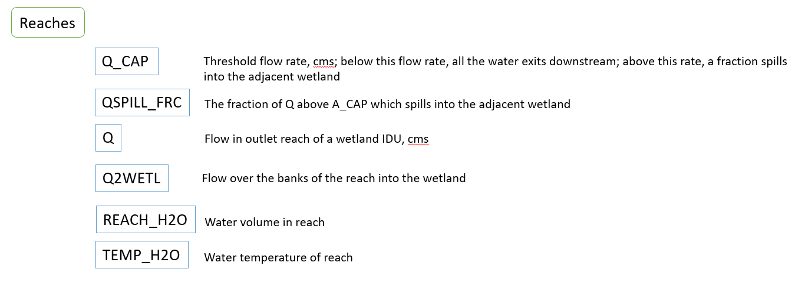

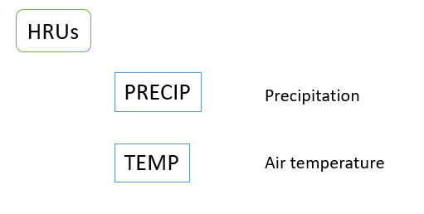

Figure . CW3M: Wetland Persistence; linking attributes to processes

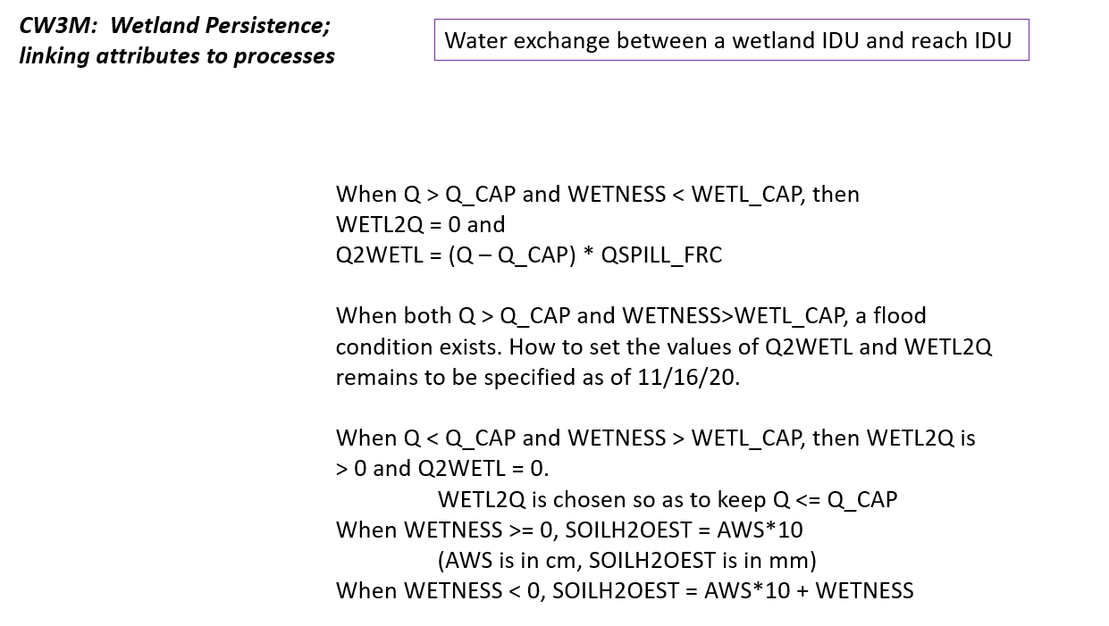

# Placeholder data

Until better data is available, here are the wetland categories and other data which will be used for code development.

## Original wetland land use/land cover categories at the beginning of the project

|  |  |  |
| --- | --- | --- |
| LULC_A | LULC_B | VEGCLASS |
| 6 Wetlands | 61 Wetlands | 190 Woody Wetlands |
|  |  | 195 Herbaceous Wetlands |

## Wetland land use/land cover categories to be used for code development

## Transitions for the state-and-transition model

Placeholder transitions remain to be developed as of 7/15/21. Final definitions of land use/land cover categories and transitions for the STM remain to be worked out by other project collaborators outside Oregon Freshwater.

# References

Poiani KA and Johnson WC (1993). A Spatial Simulation Model of Hydrology and Vegetation Dynamics in Semi-Permanent Prairie Wetlands. Ecological Applications 3(2): 279-293 (May 1993). <http://www.jstor.com/stable/1941831>

VDDT – Vegetation Dynamics Development Tool. [https://essa.com/explore-essa/tools/vddt](https://essa.com/explore-essa/tools/vddt%20%20)